Eyeconic - Glasses Shop Management System

Order (User)

Version 1.0

Revision History

|  |  |  |  |
| --- | --- | --- | --- |
| **Date** | **Version** | **Description** | **Author** |
| 29/11/2019 | 1.0 | The first version of cancel order | Hoàng Tiến Long |

Table of Contents

1. Introduction 4

1.1 Purpose 4

1.2 Scope 4

1.3 Definitions, Acronyms, and Abbreviations 4

1.4 References 4

1.5 Overview 4

2. Flow of Events—Design 4

3. Derived Requirements 6

# Introduction

## Purpose

This document describes how the Cancel Order use case is realized within the design model.

## Scope

This document applies to the Eyeconic - Glasses Shop Management System.

## Definitions, Acronyms, and Abbreviations

None.

## References

None.

## Overview

In the following section, Use-Case Realization Specification of the Cancel Order use-case of the Eyeconic is provided in detail. The first section is a textual description of the Use-Case specification. The following section contains sequence diagrams describing how the use case is realized in terms of collaborating objects. The third section includes class diagrams with relationships that participate in the realization of the use case. The last section is an analysis of all requirements, such as non-functional requirements, on the use-case realization that are not considered in the design model, but that need to be taken care of during implementation.

# Flow of Events—Design

**2.1. Use-Case Specification**

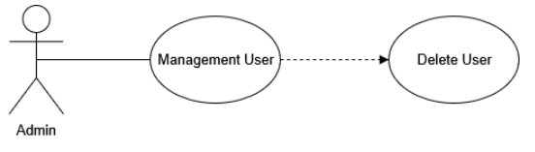

|  |  |  |  |
| --- | --- | --- | --- |
| **Name** | | | Cancel Order |
| **Brief Dexcription** | | | User cancels new orders into the website. |
| **Actors** | | | User |
| **Flow of Events** | | | |
| **Basic Flow** | | | |
| Step 1: Click the cancel order button in order management (user-side).  Step 2: Confirm to cancel the order.  Step 3: System displays order view in the website. | | | |
| **Alternative Flows** | | | |
| **Title** | | **Description** | |
| Invalid information entered | | 1. User enters invalid information.  2. System displays information with appropriate message to correct invalid information. | |
| **Pre-Conditions** | | | |
| The canceled order had not existed in the database before. | | | |
| **Post-Condition**  User checks the order view page and the website to ensure that the new order is canceled successfully. | | | |
| **Title** | **Description** | | |
| Success | Success message is prompted and the order is canceled to database. | | |
| Failure | The user is unable to cancel order to site for one or more reasons and an error is prompt. | | |
| **Extension Points** | None | | |

**2.2. Sequence Diagram**

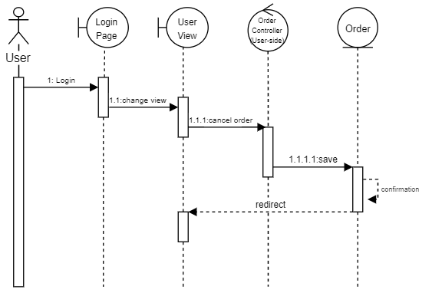

**2.3. Class Diagram**

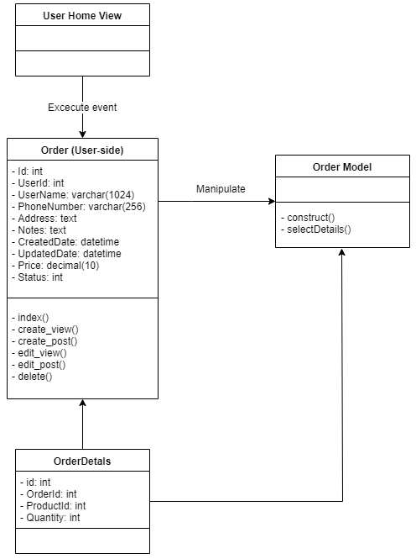

# Derived Requirements

None.